1.

public class Main {  
 public static void main(String[] args) {  
 String string = "abcde";  
 Stack stack = new Stack(string.length());  
   
 for (int i = 0; i < string.length(); i++) {  
 stack.push(string.charAt(i));  
 }  
   
 StringBuilder newString = new StringBuilder();  
 for (int i = 0; i < string.length(); i++) {  
 newString.append(stack.pop());  
 }  
   
 System.*out*.println("Original sequence: " + string);  
 System.*out*.println("Reversed sequence: " + newString);  
 }  
}

class Stack {  
 private int top;  
 private int maxSize;  
 private char[] stackArray;   
  
 Stack(int size) {  
 maxSize = size;  
 stackArray = new char[maxSize];  
 top = -1;  
 }  
  
 public boolean isStackEmpty() {  
 return top == -1;  
 }  
  
 public boolean isStackFull() {  
 return top == maxSize - 1;  
 }  
  
 public void push(char x) {  
 if (isStackFull()) {  
 System.*out*.println("Stack is Full");  
 } else {  
 stackArray[++top] = x;  
 }  
 }  
  
 public char pop() {  
 if (isStackEmpty()) {  
 System.*out*.println("STACK EMPTY");  
 return '\0';   
 }  
 return stackArray[top--];  
 }  
}

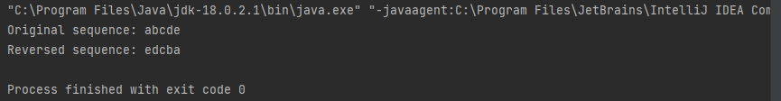

2.